Create a react app for Student Management Portal named scorecalculatorapp and create a function component named “CalculateScore” which will accept Name, School, Total and goal in order to calculate the average score of a student and display the same.

**App.js :**

import React from 'react';

import './App.css';

import CalculateScore from './Components/CalculateScore';

function App() {

  return (

    <div className="App">

      <CalculateScore name="Aniketh Reddy" school="Bharath University" total={480} goal={6} />

    </div>

  );

}

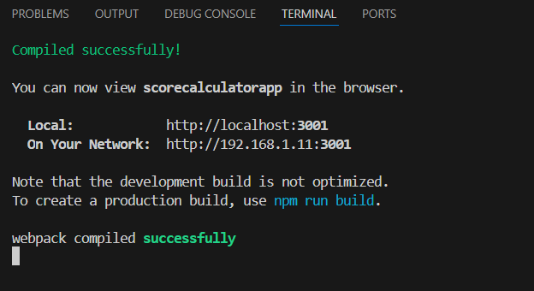export default App;

